Week7_Ticket Raising App using React Forms (mailregisterapp)

Objective:
- Create a React App named “mailregisterapp” which will have a component named “register.js”. Create a form which accepts the name, email and password and validate the fields as per the following:
- Name should have atleast 5 characters
- Email should have @ and .
- Password should have atleast 8 characters.
- Ensure that validations are implemented through eventhandle and eventsubmit of a form.

Phase 1: Setting Up Your Development Environment
Step 1: Install Node.js and npm
- Explanation: Node.js is a JavaScript runtime that lets you run JavaScript on your computer. npm is the package manager for Node.js, used to install and manage project dependencies like React.
- Action:
- Open a web browser and navigate to the official Node.js download page: https://nodejs.org/en/download/
Step 2: Install Visual Studio Code
- Explanation: Visual Studio Code (VS Code) is a free, powerful code editor that is highly recommended for React development.
- Action:
- Go to the official VS Code website: https://code.visualstudio.com/
- Download and run the installer for your operating system.

Phase 2: Creating and Running the React Application
Step 3: Create the React Application
- In your command prompt or terminal, navigate to the directory where you want to store your project (e.g., your Desktop or a development folder).
- Type the following command and press Enter. This may take a few minutes to complete.
npx create-react-app mailregisterapp
Step 4: Navigate into Your New Project Folder
- You must be inside the project folder to run commands related to this specific application.
- Once the command from Step 4 is finished, type the following command to move into the newly created directory:
cd mailregisterapp
Step 5: Open the Project in Visual Studio Code
- This command opens the entire project folder in VS Code, allowing you to easily browse and edit the project files.
- Type the command:
code .
Note: The . tells VS Code to open the current directory.

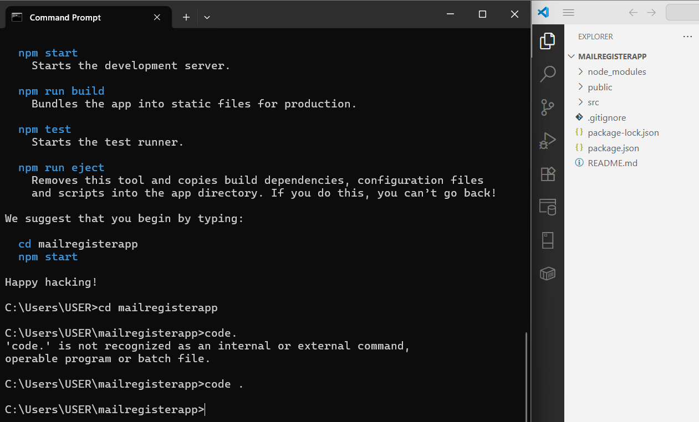
Step 6: Create the Register.js File
- In the VS Code explorer, right-click the src folder.
- Select "New File" and name it Register.js.
import React from 'react';
import './Register.css';
class Register extends React.Component {
constructor(props) {
super(props);
this.state = {
fullName: '',
email: '',
position: '',
password: '',
errors: {
fullName: '',
email: '',
position: '',
password: ''
}
};
}
handleChange = (event) => {
const { name, value } = event.target;
let errors = this.state.errors;

switch (name) {
case 'fullName':
errors.fullName = value.length < 3 ? 'Full Name must be at least 3 characters long!' : '';
break;
case 'email':
errors.email = /^[^\s@]+@[^\s@]+\.[^\s@]+$/.test(value) ? '' : 'Email is not valid!';
break;
case 'position':
errors.position = value.trim() === '' ? 'Position is required!' : '';
break;
case 'password':
errors.password = value.length < 6 ? 'Password must be at least 6 characters long!' : '';
break;
default:
break;
}
this.setState({ errors, [name]: value });
};
handleSubmit = (event) => {
event.preventDefault();
const { fullName, email, position, password, errors } = this.state;
// Simple validation check
if (
fullName && email && position && password &&
Object.values(errors).every((err) => err === '')
) {
alert(`Thanks ${fullName}!\nPosition: ${position}\nYour registration is successful.`
);
} else {
alert('Please fill out all fields correctly.');
}
};
render() {
const { errors } = this.state;
return (
<div>
<h2>Register</h2>
<form onSubmit={this.handleSubmit}>
<label>Full Name:</label><br />
<input type="text" name="fullName" onChange={this.handleChange} /><br />
<span style={{ color: 'red' }}>{errors.fullName}</span><br />
<label>Email:</label><br />
<input type="text" name="email" onChange={this.handleChange} /><br />
<span style={{ color: 'red' }}>{errors.email}</span><br/>
<label>Position:</label><br />
<input type="text" name="position" onChange={this.handleChange} /><br />
<span style={{ color: 'red' }}>{errors.position}</span><br />
<label>Password:</label><br />
<input type="password" name="password" onChange={this.handleChange} /><br />
<span style={{ color:'red' }}>{errors.password}</span><br /><br />
<button type="submit">Submit</button>
</form>
</div>
);
}
}
export default Register;
Step 7: Edit the Main App.js File
- Open the App.js file from the src folder.
- Replace all of its content with this code:
import React from 'react';
import Register from './Register';
function App() {
return (
<div className="App">
<Register />
</div>
);
}
export default App;

Step 8: Create the Register.css File

/* Register.css */
.form-container {
max-width: 400px;
margin: 40px auto;
padding: 25px;
background-color: #f9f9f9;
border-radius: 12px;
box-shadow: 0px 0px 15px rgba(0, 0, 0, 0.1);
font-family: 'Segoe UI', sans-serif;
}
h2 {
text-align: center;
color: #333;
}
label {
font-weight: bold;
color: #444;
}
input[type="text"],
input[type="password"] {
width: 100%;
padding: 8px 10px;
margin-top: 5px;
margin-bottom: 15px;
border: 1px solid #ccc;
border-radius: 6px;
font-size: 14px;
}
button {
width: 100%;
padding: 10px;
background-color: #4a90e2;
color: white;
font-size: 16px;
font-weight: bold;
border: none;
border-radius: 6px;
cursor: pointer;
}
button:hover {
background-color: #357ab8;
}
span {
font-size: 12px;
color: red;
}
Step 10: Run the Application
- Go back to your terminal (it should still be in the mailregisterapp folder).
- Run the start command:
npm start

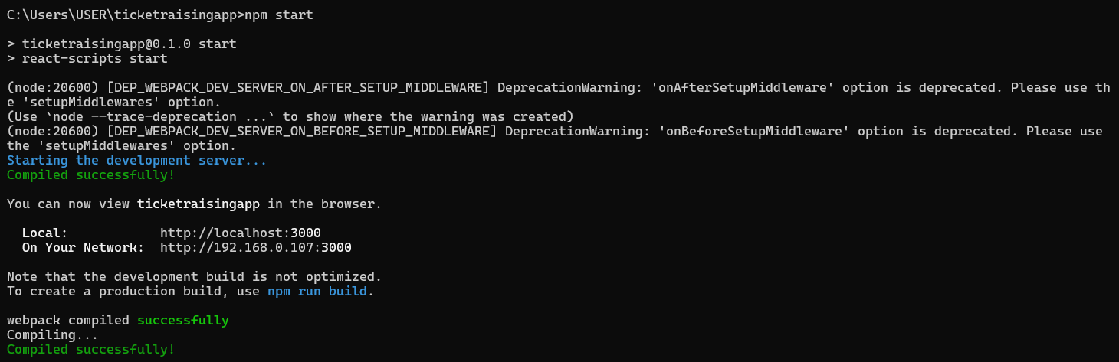
Step 11: View Your Application
- The development server hosts your application on a local port, typically 3000.
Local: http://localhost:3000
On Your Network: http://192.168.0.107:3000
Output:

